**A New Meal**

**Readings:** Luke 22:19-20

Then Jesus took some bread and thanked God for it. He broke off some pieces, gave them to the apostles and said, ‘This is my body that I am giving for you. Eat this in remembrance of me.’ In the same way, after supper, Jesus took the cup of wine and said, ‘This cup represents the new agreement from God to his people. It will begin when my blood is poured out for you.’

**Thought about the readings**

At the beginning of April, it will be Easter. This is when we think about how Jesus died for us on a cross on Good Friday and how he came back to life on Easter Sunday.

Before all that happened, Jesus had one last meal with his followers. It was a special celebration called ‘Passover’ when the Jewish people remembered how God had rescued them from slavery from Egypt.

Jesus broke some bread and shared it with his followers. He told them it was his body and to eat it so that they could remember him. Then he gave them a cup of wine to drink. He told them it was his blood poured out for them.

Of course, it was not really his body or his blood, but when they ate and drank the bread and wine in future, it helped them to remember what he had done.

This was the first Holy Communion. Jesus wants us to remember what he did at that first Easter time. When we take Holy Communion, we eat the bread and drink the wine like his first followers. It is something that we celebrate with other followers of Jesus. Sadly, we are not able to do this at the moment, because of the COVID restrictions, but we look forward to a time when we can take Holy Communion together again.

**Prayer**

Lord Jesus, thank you for giving us Holy Communion to help us remember what you did for us.

Thank you that you died for us and you rose from the dead and now you are alive for ever. We look forward to celebrating this soon through Holy Communion with our brothers and sisters in God’s family.

Amen

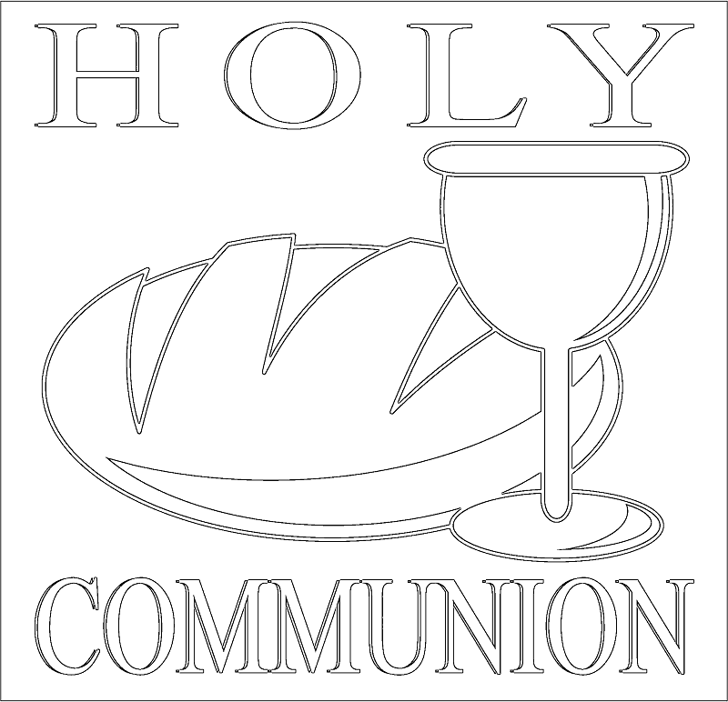

**Happy Easter to everyone!**

Christ has died

Christ has risen

Christ will come again!

**Cambridge Causeway**

Spring 2021

Bible Study notes

**All Things New:**

**A New Meal**

By Chrissy Cole